Summer 2020 Preparation
A-Level Art and Design

Why study Art and Design at Magna?
Magna Academy boasts a vibrant and lively Art Department taught by experienced practitioners with backgrounds in painting, textiles, sculpture, photography, video art and installation. Through studying your A Level Fine Art course at Magna you will enjoy exploring and refining your skills in a wide variety of materials, techniques and processes, become immersed in your artistic practise in an environment that welcomes creativity, nutures independence and celebrates hard work and ambitious, exciting outcomes!

The purpose of your task
To develop and refine your observation drawing skills by looking more closely at things around you that you see every day, and to explore skills in creating drawings from imagination.
- To develop your imagination and divergent thinking skills in response to a variety of topics and starting points.
- To understand the pace, quantity and quality of work expected at A Level standard.

Your task
What?
Create a visual art journal which reflects aspects of your own life and personality in a small A5 sketchbook or altered book.

How?
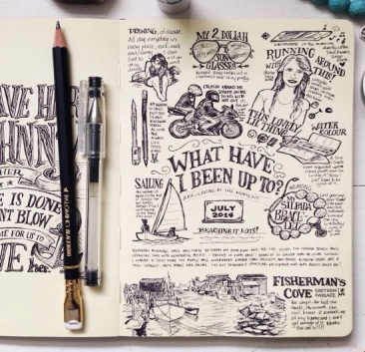
Use a combination of drawings, paintings and text/words to illustrate the suggested
themes using a range of materials, techniques and processes.

To begin with you will need a sketchbook.
Try to use one that is no bigger than A5 in size to create your journal. It’s also just as easy to make your own. Just use whatever you have available at home. Check out the links and look on YouTube for ideas linked to handmade artist sketchbooks.

Each double page will have a theme. You can draw from direct observation, use your own photos or find images on the internet as inspiration. You can also collage things into your journal and draw on top of them (e.g. receipts, tickets, wrappers, scrap paper, envelopes, postcards, flyers, newspapers, etc.)

I have given you starting points for 30 pages to fill a sketchbook but aim for at least 5 really high quality double sketchbook pages before 7th September 2020.
Recommended reading & activities list:
- https://www.accessart.org.uk/sketchbooks-an-online-course-for-children-families-parents-teachers/?fbclid=IwAR0eXgOhXUnmJdtsLP-0-SaSrYINphDO0pQP2KlcHuOGrEHLQMQpDJc2IYk
- https://www.studentartguide.com/articles/art-sketchbook-ideas
- http://josenaranja.blogspot.com/
- https://www.thisiscolossal.com/2018/04/handmade-sketchbooks-by-jose-naranja/
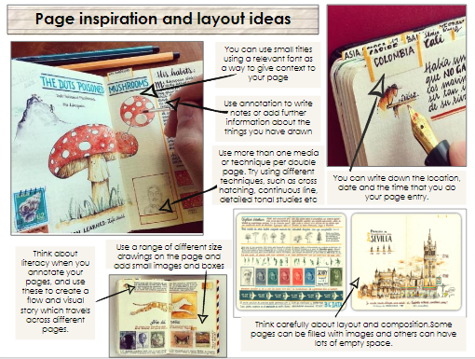
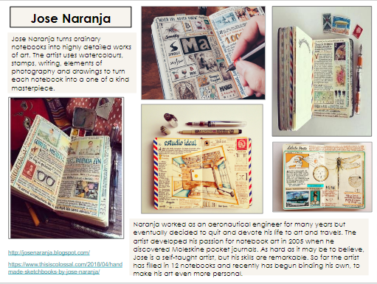
- https://www.sketchbookproject.com/

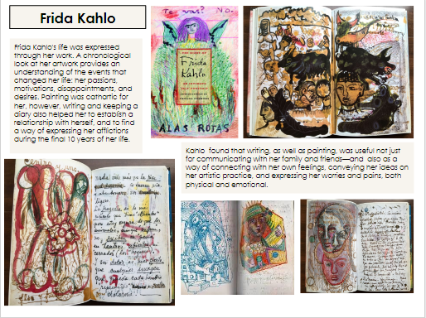
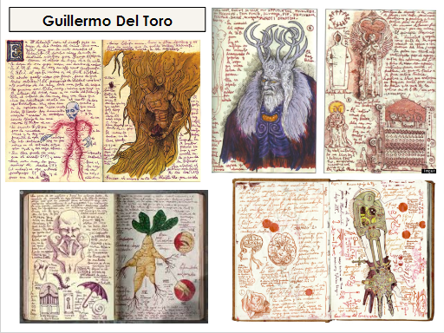
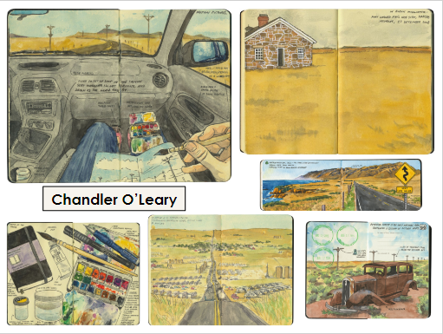

Recommended resources
- Sketchbook – A5 size (pre-bought or handmade)
- A variety of Art materials, e.g.

  - Drawing pencils (HB/2B/4B/etc)
  - Ruler
  - Rubber
  - Sharpener
  - Glue stick
  - Fine liner pen
  - Biros
  - Watercolours
  - Acrylic paint
  - Paintbrushes
  - Pastels (soft/oil)
  - Inks

You don’t have to have all of these but do try and explore as many as possible!

Things to consider
- Fill your sketchbook with as many of the page ideas as you can (listed across the next page). Min. 5 high quality double-pages.
- Look at a variety of source material but draw from direct observation as much as possible. Consider views and objects in and outside of your home, people, pets… even something unusual that catches your eye!
- Don’t forget what you have learned about the formal elements – line, tone, shape, form, light, shadow, composition, texture, pattern, etc.
- Be explorative, imaginative and most importantly have fun!

