[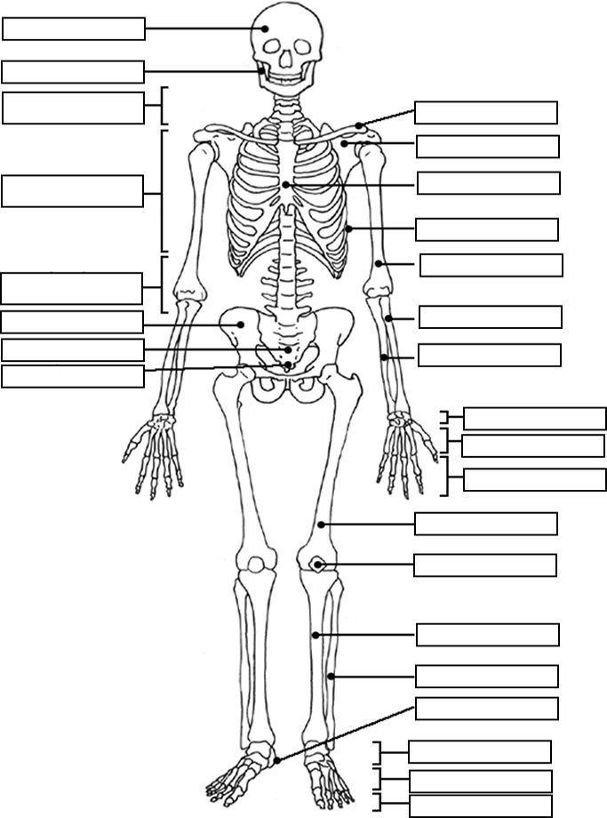](https://www.google.co.uk/url?sa=i&url=https%3A%2F%2Fwww.pinterest.com%2Fpin%2F138767232254394413%2F&psig=AOvVaw2Ul9nfJ3r4TnWrQXrwprw3&ust=1589534813059000&source=images&cd=vfe&ved=0CAIQjRxqFwoTCIibxN6Es-kCFQAAAAAdAAAAABAT)