[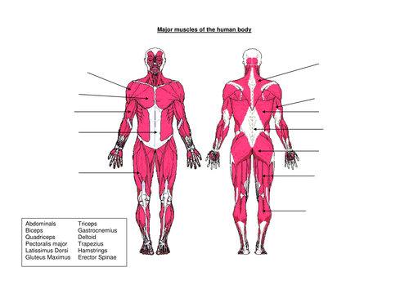](https://www.google.co.uk/url?sa=i&url=https%3A%2F%2Fwww.tes.com%2Fteaching-resource%2Fmuscles-of-the-human-body-6077821&psig=AOvVaw1DZggsaR-73HVWJ9_5SsU7&ust=1589535316634000&source=images&cd=vfe&ved=0CAIQjRxqFwoTCNjw_dmGs-kCFQAAAAAdAAAAABAD)