[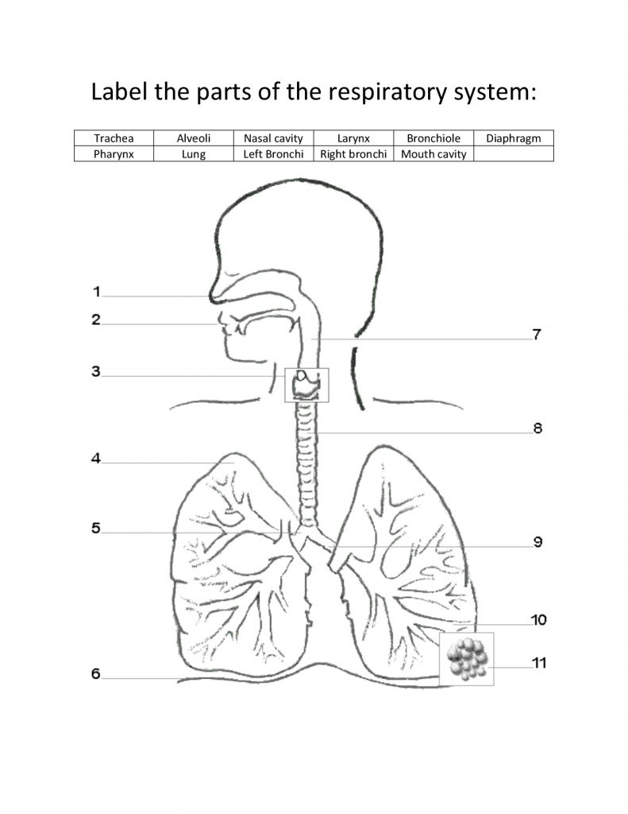](https://www.google.co.uk/url?sa=i&url=https%3A%2F%2Fwww.pinterest.com%2Fpin%2F412290540878153069%2F&psig=AOvVaw3xLu8J0OvNZh6dWo_xHqWe&ust=1589535740154000&source=images&cd=vfe&ved=0CAIQjRxqFwoTCNiotKCIs-kCFQAAAAAdAAAAABAK)