[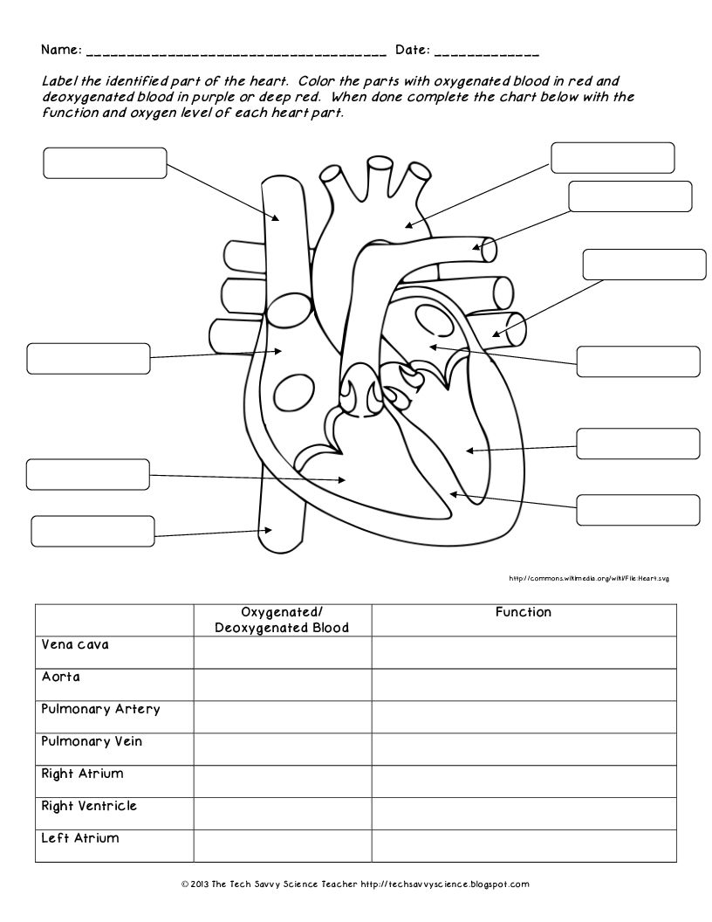](https://www.google.co.uk/url?sa=i&url=https%3A%2F%2Fwww.pinterest.se%2Fpin%2F316307573827228110%2F&psig=AOvVaw1sTm3fqmAZhyxwxWK8tmcO&ust=1589535441467000&source=images&cd=vfe&ved=0CAIQjRxqFwoTCIisw46Hs-kCFQAAAAAdAAAAABAK)